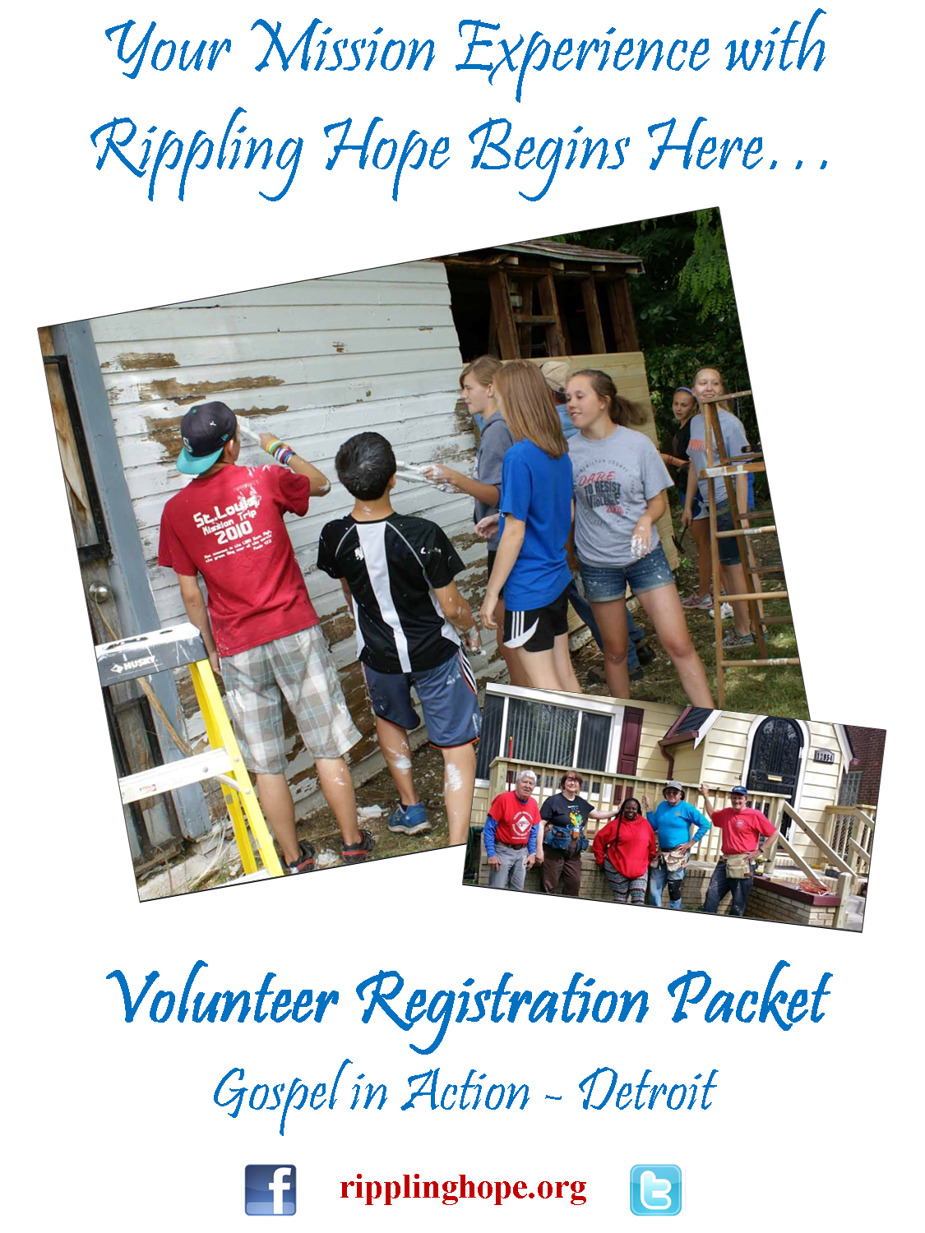
RIPPLING HOPE
Connecting Communities…Channeling Hope …Changing Lives
Welcome Volunteers!
We are excited that you have said “yes” to participating with Rippling Hope in our Gospel in Action—Detroit program. The work and people you will experience will be life changing! You will make meaningful connections as you serve in local communities helping your neighbors who are in need of minor home repairs or blight reduction measures. Rippling Hope is proud to be currently partnering with over 55 block club/neighborhood association leaders in Northwest Detroit. These connections as well as many other local partnerships help Rippling Hope offer the resources and expertise to enrich the lives of your group members and make your service experience memorable.
While in Detroit you will be helping to rebuild and revitalize one part of the city. Over the past 7 years volunteers have worked on over 2230 homes. Requests for our services continues to grow, so there will be plenty of ways for you to serve while you are here. The service projects you will be engaging in will include any one or more of the following:
Home repairs; House Painting (interior/exterior); Garage Painting; Toilet & Faucet Replacement; Building Handicap Ramps; Porch & Step Repair/Replacement; Installation of Door Locks, Security and Storm Doors and Interior Door Knobs; Neighborhood Cleanup, Boarding up vacant homes.
We hope that this packet of information will answer some of your basic questions and help you prepare in advance for your trip and experience. We encourage you to take some time to read the information in this Volunteer Packet, and to share it with your group. Please pay special attention to the pages about “SASA”, Service, Awareness, Safety & Adaptability. You will also find several IMPORTANT FORMS (t-shirt order, payment invoice, individual registration, and waiver & release of liability) in this packet. You may plan to bring the Waiver & Release Forms with you. Please return the other forms by the dates listed on them. We will be sending you a contact and direction sheet closer to your travel dates.
We are expecting groups to arrive by supper at 6:30 PM on Sunday; to work Monday-Friday (half-day Friday); and to leave on Saturday morning. If this schedule is not going to work for your group, please let us know at your earliest opportunity. We have included a typical weekly and daily schedule in this packet to give you an idea of what your service week will look like. We do encourage groups to use Friday afternoon and evening to experience the cultural opportunities in and around Detroit. For some ideas please go to www.visitdetroit.com.
At all times before and during the course of this service experience you can reach us at: Carl (512-619-0575, carl@ripplinghope.org) or Robin (512-619-0782, robin@ripplinghope.org).
Please check out our Facebook page (www.facebook.com/pages/Rippling-Hope) and “like” us and our website (www.ripplinghope.org) and invite your group participants to do the same to follow the work as it unfolds in Detroit this year.
Thank you again for saying “yes” to God’s call to service, and your partnership with Rippling Hope and our neighbors in Detroit! Your efforts will make a world of difference, and lives will be changed!
Peace,
Carl E. Zerweck, III Robin Zerweck
Executive Director Administrator
512-619-0575, carl@ripplinghope.org 512-619-0782, robin@ripplinghope.org

Release & Waiver of Liability

PLEASE READ CAREFULLY! THIS IS A LEGAL DOCUMENT THAT AFFECTS YOUR LEGAL RIGHTS!

THIS RELEASE & WAIVER OF LIABILITY (“Release”) is executed on this date _________________________, by the Volunteer & if there is a parent having legal custody and/or the legal guardian of the Volunteer (“Guardian”), in favor of Rippling Hope; its directors, officers, employees & agents (hereinafter collectively referred to as “Rippling Hope”). The Volunteer and/or Guardian desire that the Volunteer participate in volunteer work projects & the activities related to volunteer work projects in _________________________. The Volunteer and/or Guardian understand that the activities may include general cleanup, debris removal, repairs, travel to & from the site(s) & consuming food & inhabiting living accommodations donated for the volunteers (hereinafter collectively referred to as “Work Projects”).

The Volunteer and/or Guardian do hereby freely, voluntarily & without duress execute this Release according to the following terms:

1. Waiver & Release. In consideration of the Volunteer being allowed to participate in the Work Projects identified by Rippling Hope, the Volunteer and/or Guardian do hereby release & forever discharge & hold harmless Rippling Hope & its successors & assigns from any & all liability, claims, damages & demands of whatever kind of nature, either in law or in equity, which arise or may hereafter arise from Volunteer's participation in the Work Project. Volunteer and/or Guardian understand that this Release discharges Rippling Hope with respect to bodily injury, personal injury, illness, death or property damage that may result from Volunteer's participation in the Work Projects. Volunteer and/or Guardian also understand that Rippling Hope does not assume any responsibility for, or obligation to provide financial assistance or other assistance including but not limited to medical, health or disability insurance to the Volunteer and /or Guardian.
2. Medical Treatment. Volunteer and/or Guardian do hereby release & forever discharge Rippling Hope from any claim whatsoever which arises or may hereafter arise on account of any first aid treatment or service rendered or not rendered in connection with the Volunteer's participation in the Work Projects or with the decision by any representative or agent of Rippling Hope, to exercise or not exercise the power to consent to medical or dental treatment as such power may be granted & authorized in the Parental Authorization for Treatment of a Minor Child.
3. Assumption of the Risk. The Volunteer and/or Guardian understand that the Work Projects may include activities that may be hazardous to the Volunteer & that the food, accommodations & medical facilities may be donated to Rippling Hope & that therefore the quantity, quality & suitability is beyond their control; and, therefore Volunteer and/or Guardian assume all risks associated with the Work Projects, food, accommodations & medical facilities, or the lack thereof.
4. Insurance. The Volunteer and/or Guardian understand that Rippling Hope does not carry or maintain health, medical or disability insurance coverage for any Volunteer. Each Volunteer is expected & encouraged to arrive with medical or health coverage in effect.
5. Photographic Release. Volunteer does hereby grant & convey unto Rippling Hope all right, title & interest in any & all photographic images & video or audio recordings made by Rippling Hope during the Volunteer’s activities, including, but not limited to, any royalties, proceeds, or other benefits derived from such photographs or recordings.
6. Other. Volunteer and/or Guardian expressly agree that this Release is intended to be as broad & inclusive as permitted by applicable law. The Volunteer and/or Guardian stipulate & agree that this Release shall be governed by the laws of the State of Washington, the State of incorporation & the domicile of Rippling Hope, without regard to the Washington’s choice of law provisions. Volunteer and/or Guardian agree that in the event that any clause or provision of this Release shall be held to be invalid by any court of competent jurisdiction the invalidity of such clause or provision shall not otherwise effect the remaining provisions of this Release which shall continue to be enforceable.

IN WITNESS WHEREOF, Volunteer has executed this Release as of the day & year first above written.

Volunteer_____________________________________________________________________________

Address______________________________________________________________________________

Phone(s) (H) ___________________________________ (C) __________________________________

Emergency Medical Information

In case of emergency, please contact:

Name: _______________________________________ Relationship: _____________________

Address: ______________________________________________________________________

Phone(s) (H) ___________________________________ (C) __________________________________

Health Information—please lists any allergies, health problems, medications, etc. that we need to be aware of:

Date of last tetanus_____________________________________________________________

Health Insurance:
Company ____________________________________Policy #_________________________
(Please bring your health insurance card with you.)

PLEASE BRING THIS FORM TO THE WORK SITE WITH YOU!

What to Bring
PLEASE NOTE: For cultural awareness & safety issues, please do not wear pants shorter than knee length—long pants preferred. NO halter tops, spaghetti straps, tank tops or yoga/biking pants FOR WORK. Required work shoes—NO open toed shoes!
Work Clothes
Work Shoes
Tennis/Casual Shoes
Casual Clothes & Sweatshirt
Toiletry Items
Towels & Washcloth
Pillow & Sleeping Bag
Air mattress or cot (lodging is sleeping on the floor)
Sun Block
Sunglasses
Devotional material to share in worship
Bible
Rain Gear
Flashlight
Recreational Items
Games
Shower Shoes
Insect Repellant
Safety Glasses (if you have them)
Work Gloves
Personal Tool Belt (if you have one)
Hammer
Tape Measure
Speed Square
Utility Knife

Individual Participant Registration
(Please complete for each individual in your group and return with your payment invoice below)
INDIVIDUAL PARTICIPANT REGISTRATION FORM

Name: First: _______________________________________ Last: _________________________________________

Home Address: _______________________________________________________________________________ ___

City: _____________________________________________ State: _____________ Zip Code: __________________

Phone: Work ____________________________________ Cell: __________________________________________

Email: ________________________________________________________________________________________

Date Of Birth: ______________________________ Age: ______________

Congregation/Organization: _______________________________________________________________________

Address: ______________________________________________________________________________________

City: _____________________________________________ State: ______________ Zip: ______________________

Payment Invoice
Due: Two Weeks Prior to Your Group’s Arrival

Please Make Check Payable to: Rippling Hope

___Adults and/or Youth 11 & Over @ $299.00_______

___Children age 10 & under @ $175.00________

TOTAL DUE ______

Name of Group:

Contact Person: ______________________________________

Contact Info: _________________________________________
for the person named above

Mail forms and your payment to:
Rippling Hope
P O Box 27499
Detroit, MI 48227

TYPICAL WEEKLY & DAILY SCHEDULE

Typical Mission Week is Sunday Dinner through Saturday Breakfast

Sunday Group Arrives & Settles In Mid-late afternoon

Dinner 6:00/6:30 PM

Orientation 7:00/7:30 PM

Monday-Friday: Breakfast 7:30 AM

Kitchen Clean-up/Make Lunches Following Breakfast

Load Work Tools 8:30 AM

Leave for Worksites 9:00 AM

Work (regular water breaks) 9:15 AM -12:15 PM

Lunch (On Site) 12:15 – 12:45 PM

Work 12:45 - 4:00 PM

Return from Worksite 4:00 - 4:30 PM

Unload Work Tools – Clean-up/
Showers & Free time 4:30 - 6:00 PM

Dinner & Kitchen Clean-up 6:00 – 7:00 PM

Debrief From the Day 7:00 – 7:30 PM

Group Free Time/Devotions/Activities 7:30 – 10:30 PM

Lights Out 10:30 PM

Tips for a Quality Mission/Service Experience

*Service
*Awareness
*Safety
*Adaptability

Service
Each of us are called by God to lives of faith lived out in service to and with others. All that we do as people of faith ought to reflect this spirit of God that calls us (our attitudes, willingness to work, ways we interact with each other, and all those we come into contact with). You will be part of a unique community that is coming together to say "yes" to this call in your lives. We give thanks to God for calling this particular group of people, at this time, and in this special place, as we work together to reach out and serve with our neighbors in need. In so doing, we give witness to the love of God.

Awareness
Awareness occurs on many levels, but in mission/service experiences, we want to be especially prepared to deal with both awareness of others and cultural awareness issues.

Always remember that you are guests and servants. Thinking about how guests act when they visit
someone's home, is helpful as you enter into someone else's “home.” Your attitude of servanthood is
also helpful as you work together with your hosts. Try to serve “with” and not “for” your hosts.

Be aware of those we have come to serve and serve with:

Take time to meet and talk with family (if they are available), at the beginning and end of each work day.

Ask them for their ideas and encourage them to join in the work.

Keep reactions to yourself that might hurt or insult the family and/or community members (i.e.: who picked that paint color, chose this or that?).

Be sensitive to the family's need for space and privacy. Ask before venturing into new areas of the home...always remember that you "come as guests invited."

Don't bring out cameras until a relationship has been established and then ALWAYS ask permission. Take pictures of people you want to remember, and of the ongoing work. To ensure sensitivity to the families we serve, the use of video cameras should be strictly prohibited without their prior approval. The same is true of the community you are working in. Be aware that in any community there may be people who, for a variety of reasons, DO NOT wish for their picture to be taken and shared anywhere.

Be aware of community issues like TIME---are you beginning work at 6 AM? Is that too early? Are you loud and rowdy at night? Can neighbors hear you? SPACE---be sure to be aware of whose space you are in...does someone own the property you are walking across, eating lunch in, or parking your vehicles in front of? CULTURAL NORMS---be aware of how you act and dress in public at all times, and how you will be viewed by those who live there.

Expect to meet a host of saints. One of the most rewarding benefits you'll experience is that you will meet saints in the organizations, churches and communities where you are involved. Watch for them, learn from them, and experience the holy in them. Your life will be enriched from your encounters with these folk.

Plan to provide your own transportation. Be aware that even if an organization has a van, it's likely for a reason. If they are using it to transport you around for a week, it is not likely being used as it might be needed. Be sensitive to their need to use their transportation for their activities.

Be aware of work/compassion fatigue with the staff. While some of the staff of the organizations you work with might be paid, many will likely be volunteers, summer interns, and all likely working many hours for little compensation. Many of these folks will wear multiple hats and do multiple jobs. As much as possible, be as independent as you can be once the work/mission week starts. Be aware that the life and ministry of the churches, organizations, and individuals you are working with goes on BEFORE, DURING and AFTER your week with them. It never hurts to say "Thank You" for sharing their time and talents with you.

Safety

We always stress safety as number one! Talk about how important it is to be safe in all situations. This especially needs to be stressed with skilled workers you may have on your team who are not used to working with unskilled volunteers. They need to think safety at all times.

- The most necessary tool – your brain
- The most important tool – patience
- Be aware of people around you – others are working all around you…remember the lumber you’re carrying has two ends!
- Keep work areas clean – help put away tools and supplies at the end of the day
- Ask for help – if you are uncomfortable performing a task or just have a question, just ask and we’d be more than happy to help
- Be aware of trip hazards – cords, lumber, bolts on slab…keep yourself and others safe by storing things against walls, etc.
- Wear appropriate clothing – no open-toed shoes/sandals/heels
- Wear safety gear – goggles, masks, respirators, and gloves will always be available when needed
- Lift with your legs and not with your back
- Take breaks and drink lots of fluids – water, sport drinks, etc…accidents occur more often when you’re tired
- Be aware of first aid supplies – be sure to know where first aid kits are located and ask if you need help
- Never leave nails sticking out of wood – don’t bend them over, take them all the way out
- Only operate power tools that you know how to use – we’d be happy to teach you to safely use any tool
- Only operate power tools that are in safe, good working order – be aware of frayed cords and removed or broken safety guards
- Place ladders on even ground – please don’t use blocks to level a ladder…dig out the ground for a firm base
- Be sure ladders are fully extended – the ladder is at the correct angle if your fingers can just touch a rung with your feet at the base
- Never stand on the top of a ladder – stop and get a bigger ladder for your safety and the safety of those below
- Be careful on a roof – surfaces can be slippery when wet or dusty, and never set something down unless it is secured and cannot fall

Adaptability

We have learned over the years that although we all do great planning and preparing for experiences like your mission/service experience, that sometimes there are little bumps in the road or little hiccups along the way. We remember that we are called to God's service, and we are operating on God's time. Therefore we all must practice the virtue of adaptability. Sometimes we will be diverted from our planned tasks to take on another task. Sometimes the paint, or lumber, or supplies won't be there when we arrive at a work site. We try to practice abundant grace and enthusiastic adaptability in all that we do!

Always remember that you are guests and servants. Thinking about how guests act when they visit someone's home, is helpful as you enter into someone else's “home.” Your attitude of servanthood is also helpful as you work together with your hosts. Try to serve “with” and not “for” your hosts.

Don't expect a “sense of completion.” I can best explain this by sharing with you a quote from someone charged with planning work trips for groups coming to her organization. “They want a sense of completion after their three days of work. I go home every day and never feel a sense of completion. Why do I have to orchestrate one for them?” I think this is a fair question. Part of the power of the trip will be the realization that there is still much to be done to right the wrongs in this world . . . and your work helped along the journey. BE ADAPTABLE!

Be sensitive to overworked staff. Unless there is a specific person whose job description is to host work groups, you will likely be hosted by someone who usually does something else. Be aware of the fact that all the time with you means another job is not being done. As much as possible, be independent in your work once you get started. And be aware that the life and ministry of the organization does not stop when you arrive!

Remember there is more than “work” to be done. Work with the host to expose your group to the particular culture and people of the community. If team members simply went to the work site and worked without experiencing the area or its people, they would leave without a real sense of the church and community and their needs. Plans should include opportunities to be involved with the locals in activities, tour places of historical or cultural significance, etc. BE ADAPTABLE!

Schedule the itinerary with input from the hosts, balancing that with the needs and interests of the group. The hosts may have many good ideas for ways your team can spend its time, but you need to be sure your team has time for reflection and worship, free time and time to play. You know your group best and your hosts know the area and culture. Work together to ensure the best possible experience for all concerned. BE ADAPTABLE!

Expect to meet saints. One of the most rewarding benefits you'll discover is that you will meet saints of the church in these organizations. Watch for them, learn from them, experience the holy in them. Your life will be enriched from spending time with them.

If possible, bring money to help pay for supplies. Having materials on hand for every work group cost a lot of money that many organizations do not have. Some of the most welcome words they can hear are “we'll have the money to buy the supplies or help with supplies!”

Be creative with coming up with work that will help. If they haven't got enough for your group to do, look around and offer to do something more. Jobs that need little or no supervision by their staff are best. BE ADAPTABLE!

Try to provide your own transportation on site. Be aware that if an organization has a van, it's for a reason. And if they are using it to transport you for a week, it is not being used as it usually is used. Be sensitive to their need to use their transportation for their activities.

BE ADAPTABLE!
Did I mention ADAPTABILITY? Make plans... do your homework... and be prepared to have everything change before your very eyes! It's OK! You are there because you were sent there. And you will do God's work even if it's not exactly as you planned. Your spirit of adaptability & joy as you do it will bring hope & renewal to those who toil there every day. And THAT is more important than all else... that you & your group become Bearers of Hope.
T-SHIRT ORDER FORM
Rippling Hope
Connecting Communities…
Channeling Hope…
Changing Lives.

Gospel in Action
Detroit, MI
El Paso, TX

Group Name:______________________________________________

Address:__________________________________________________

City:___________________________State:_______Zip:___________

Phone #:_________________________________

Email:___________________________________

Childrens Adult Sizes
Sizes
10/12 | 14/16 | S | M | L | XL | XXL | XXXL | Other

PLEASE RETURN THIS FORM NO LATER THAN Monday, May 21
SO WE WILL HAVE THE RIGHT SIZE T-SHIRTS FOR YOUR GROUP!

RETURN TO: Rippling Hope, P.O. Box 27499, Detroit, MI 48227

OR EMAIL TO: carl@ripplinghope.org

